|  |  |  |  |  |  |  |  |  |  |  |  |  |
| --- | --- | --- | --- | --- | --- | --- | --- | --- | --- | --- | --- | --- |
| **Software Requirement Specifications**  Skillosity  Version: [1.2]   |  |  | | --- | --- | | Project Code | CS-4092 | | Supervisor | Mr. Bahraj Khan | | Co Supervisor | Mr. Shoaib Raza | |  |  | | Project Team | Hasan Salman (18k-1101)  Zulfiqar Ahmed (18k-0167)  Muhammad Hasan Aamir (18k-0206) | | Submission Date | 22-Dec-2021 | |

Document History

[Revision history will be maintained to keep a track of changes done by anyone in the document.]

|  |  |  |  |
| --- | --- | --- | --- |
| **Version** | **Name of Person** | **Date** | **Description of change** |
| 1.0 | Hasan Aamir | 14-11-21 | Document Created  Added Introduction Section |
| 1.1 | Hasan Aamir | 29-11-21 | Added Non-functional requirements |
|  |  |  | Added Use Case 1,2,3,4,5,6 |
| 1.2 | Hasan Aamir | 30-11-21 | Added Functional Hierarchy |
|  |  |  | Completed SRS |
|  |  |  |  |
|  |  |  |  |

Distribution List

[Following table will contain list of people whom the document will be distributed after every sign-off]

|  |  |  |
| --- | --- | --- |
| **Name** | **Role** | |
| Bahraj Khan | | Supervisor |
| Shoaib Raza | | Co- Supervisor |
|  | |  |

Document Sign-Off

|  |  |  |
| --- | --- | --- |
| **Version** | **Sign-off Authority** | **Sign-off Date** |
| 1.0 |  |  |
| 1.1 |  |  |
| 1.2 |  |  |
|  |  |  |
|  |  |  |
|  |  |  |
|  |  |  |

**Table of Contents**

1. Introduction 6

*1.1. Purpose of Document 6*

*1.2. Intended Audience 6* *1.3 Abbreviations ………………………………………………………………………………………...6*

*1.4. Document Convention 6*

2. Overall System Description 7

*2.1. Project Background 7*

*2.2. Project Scope 7*

*2.3. Not In Scope 7*

*2.4. Project Objectives 7*

*2.5. Stakeholders 7*

*2.5.1 Project Devlopers ..…………………………………………………………………………...7*

*2.5.2 Supervisors ..…………………………………………………………………………………..8*

*2.5.3 Users ……………………………………………………………………………………..........8*

*2.5.4 Benefited Stakeholders ………………………………………………………………………8*

*2.6. Operating Environment 8*

*2.7. System Constraints 8* *. 2.7.1 Software Constraints …………………………………………………………………………8 . 2.7.2 Hardware Constraints 8*

*2.7.3 Cultural Constraints 8 . 2.7.4 User Constraints 8*

*2.7.5 Legal Constraints 9*

*2.8. Assumptions & Dependencies 9*

3. External Interface Requirements 10

*3.1 Customer Interfaces……………………………………………………………………………......10 . 3.1.1 Admin Interfaces 10*

*3.2. Hardware Interfaces 10*

*3.3. Software Interfaces 10*

*3.4. Communications Interfaces 11*

4. Functional Requirements 12

4.1. Functional Hierarchy 12

*4.2. Use Cases 13*

*4.2.1. Register 13*

*4.2.2 Login 14*

*4.2.3 Sell a product 15*

*4.2.4 Buy a product 16*

*4.2.5 View Product Details 17*

*4.2.6 View Product Details 18*

*4.2.7 Manage User 19*

5. Non-functional Requirements 20

*5.1. Performance Requirements 20*

*5.2. Safety Requirements 20*

*5.3. Security Requirements 20*

*5.4. User Documentation 20*

6. References 21

1. Introduction

* 1. Purpose of Document

This system deals with the purchase of product that is made by using the natural skills of a person in music, animation or gaming online. This document covers details of the product, what is the problem and what solution it provides. The scope of this product is to allow people to use their natural skills to make innovative products and sell them online by safe and secure transactions.

* 1. Intended Audience

This system is an online platform for people who can use their natural skills to make their products and sell them and likewise the buyers can buy them. This SRS is intended for developers, sellers and buyers (general user).

**1.3 Abbreviations**

|  |  |
| --- | --- |
| Terms | Description |
| SQL | Structured Query Language |
| DB | Database |
| CSS | Cascaded style sheet |
| S | Stripe Payment Gateway |
| DBMS | Data Base Management System |

* 1. Document Convention

The Document uses the following conventions:

* Font Size = 10
* Font = Arial

1. Overall System Description
   1. Project Background

This technological era has produced many platforms like Tiktok and Dubsmash where you can show your skills in acting, music editing and video dubbing whereas also platforms like sellfy where you can sell your digital products on an e-commerce site. However, a platform should be developed where skills in music making, animation or gaming can be displayed as well. Therefore, Skillosity is a web platform where a content creator can easily show his/her skills to the content buyers and can make easy and instant money through it within a certain period of processing. With safe and secure money handling, the buyers can easily buy a product made by the content creator skill and pay online. With the employment rate increasing due to coronavirus, if the person is not able to achieve a good job or money, one can easily gather income from this platform using the skills they acquire. With the latest technology, the platform will be developed as a new opportunity for the content creators who possess their skills in music, animation or gaming and will get to know their worth of the skill they have. Thus, Skillosity can be seen as a revolutionary change in the world of technology where skills are valued.

* 1. Project Scope

The purpose of Skillosity is to let people with natural skills in animation, gaming and music sell their product and get instant payment. It also includes an easy-to-use web platform for buyers, who are willing to find innovative products.

The system is based on a relational database with seller’s skill based product. We will have a database server supporting the website and stripe payment gateway for safe and secure payment. Above all, we hope to provide a comfortable user experience along with innovative products and best pricing.

* 1. Not In Scope

We will not be having a physical handling of cash option as all the transactions will be done through stripe payment gateway.

* 1. Project Objectives

In this technological world where unemployment is increasing due to Coronavirus and depression issues are at peak, there must exist a system for people to use where they can utilize the skills they have in themselves and earn money through it. Unlike other platforms like YouTube, SoundCloud or Fiver where you have to wait for a long time to earn proper money, Skillosity’s objective is to let people earn quick money by showing their skills in animation, music and gaming to the world. The objective is to bring revolutionary change in the field of animation, gaming and music digitally and provide a platform where the creator is in control. Skillosity also aims to bring out best within people and motivates a person to do best for themselves through their skills. Another objective of this platform is to provide the companies and professional organizations to find the hidden talent of people and use the skillful product for organization. Skillosity can help companies to find innovation in animation, music and gaming industries which they have never seen and allow them to buy them through auction for a fair price. This can bring a huge boost to companies which are always looking for innovative ideas.

* 1. Stakeholders

This project contains several stakeholders as well. They will be accounted for in the following list:

* + 1. Project Developers

This project has three developers who are working on all the needed tasks for the project which includes project planning, development, documentation, and validation of the objectives.

* + 1. Project Supervisors

The project supervisor is Sir Bahraj Khan and Co Supervisor is Sir Shoaib Raza. They both have the role to supervise the project and guide the project developers.

* + 1. Users

The aim of this project is to develop a web platform for the public to sell their skill based product to the people who find innovation in them and are willing to buy it.

* + 1. Benefited Stakeholders

They are those who will be able to profit if we end up commercializing this web platform i.e. animation, gaming and music buyers or companies.

* 1. Operating Environment

Environment for Skillosity is listed below:

* Client/Server Program
* Operating System: Windows
* Database: MySQL
* Platform:
  + Front-end: React.js
  + Back-end: Node.js
* Stripe Payment Gateway
  1. System Constraints
     1. Software Constraints:

It can work on every operating system which supports a cross-platform web browser like Google Chrome. The browser is also one of the main components as it serves as a platform for the web apps.

* + 1. Hardware Constraints:

A System with a processor of Intel Core i3 3rd Generation with (4 CPUs) is recommended. RAM should be 4GB DDR3 or higher.

* + 1. Cultural Constraints:

The user must understand comprehend English Language because all the Interfaces are designed with English understanding in mind. Furthermore, to the user should know the working of a browser and how a website works; so that means we require our users to literate with computers.

* + 1. User Constraints:

To use the website we require that the user knows how to operate computers which means our users should be literate with computers. Therefore, very small kids are not the target audience and we require that people older than 18 should use the website. The User must also understand and comprehend English Language because all the Interfaces are designed with English understanding in mind.

* + 1. Legal Constraints:

Copyright are our rights that protect our idea from being copied or stolen by any other individual and gain profits and frame our intellectual property. Copyright protects our idea from being recreated as Copyright violation is punishable offence and is frowned upon in society.

* 1. Assumptions & Dependencies

* Updated Browser
* Internet Connectivity

1. External Interface Requirements
   1. Customer Interface

* Registration Panel
* Login Panel
* Creating a portfolio Panel
* Sell a product Panel
* Chat Interface Panel
* Buy Product Panel
* Seller Dashboard Panel
* View Product
  + 1. Admin Interface
* Manage user Panel
* View Products Panel
* Delete or Block User Panel
* Help and Support Panel
* Database Management
  1. Hardware Interfaces
* Windows
* A browser which supports HTML, React and Node js.
  1. Software Interfaces
* Operating System
* Database
* JavaScript
* React.js
* Node.js
* Stripe Payment Gateway API
  1. Communications Interfaces

The project supports all types of web browsers. We are using gigs, chat option and then transactions through stipe payment gateway.

1. Functional Requirements
   1. Functional Hierarchy
2. Functional Hierarchy of a Seller

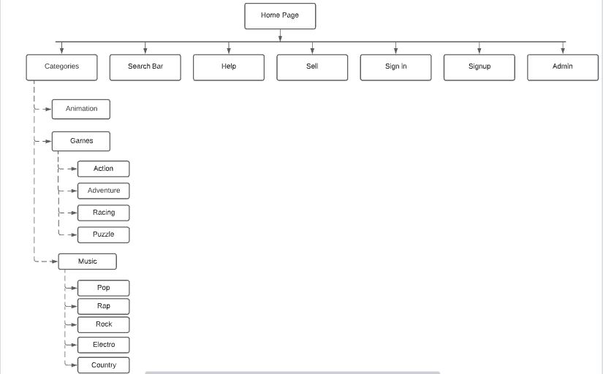

1. Functional Hierarchy of a Buyer

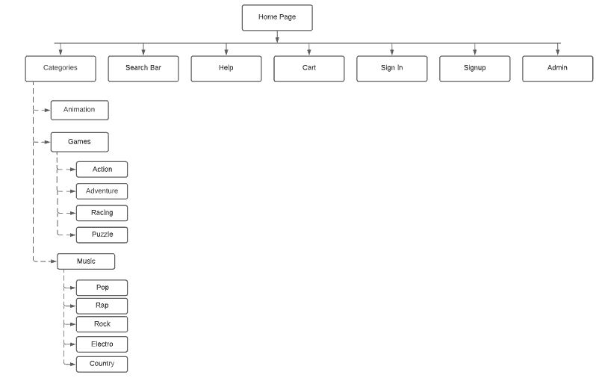

* 1. Use Cases
     1. Register

|  |  |  |  |  |
| --- | --- | --- | --- | --- |
| **<1: Register>** | | | | |
| **Use case Id:** | | 1 | | |
| **Actors:**  **Primary:** User(Seller/Buyer) **Other Actor:** Admin **Stakeholder:** Project Developer | | | | |
| **Feature:** User will register in to the system | | | | |
| **Pre-condition:** | | 1. User Must be present 2. Internet should be available | | |
| **Scenarios** | | | | |
| **Step#** | **Action** | | | **Software Reaction** |
| **1.** | User access the site | | | Home Page is shown |
| **2.** | User click on register option | | | Registration Page opens |
| **3.** | User fills the required information (Buyer or Seller) | | | Dashboard is created (Buyer or Seller) |
| **4.** | User fills the details of the acquired category. | | | Registration completed |
| **Alternate Scenarios:** 1a. Incorrect Information | | | | |
| **1a: User** is asked to re-enter the particular detail.    **2a:** | | | | |
| **Post Conditions** | | | | |
| **Step#** | **Description** | | | |
| **1.** | Registration is completed. | | | |
| **2.** | Account created in Database. | | | |
|  |  | | | |
| **Use Case Cross referenced** | | | Login | |

|  |  |  |  |  |
| --- | --- | --- | --- | --- |
| **<2: Login>** | | | | |
| **Use case Id:** | | 2. | | |
| **Actors:**  **Primary:** User(Seller/Buyer) **Other Actor:** Admin **Stakeholders:** Project Developer | | | | |
| **Feature:** User logins to the system | | | | |
| **Pre-condition:** | | 1. User Must be present 2. User must be registered | | |
| **Scenarios** | | | | |
| **Step#** | **Action** | | | **Software Reaction** |
| **1.** | User visits site | | | Home Page displayed |
| **2.** | Customer fills information and press Login | | | Main Page Displayed |
|  |  | | |  |
| **Alternate Scenarios:** 1. Incorrect Information | | | | |
| **1a:** Please re-enter your username and passwords.    **2a:** | | | | |
| **Post Conditions** | | | | |
| **Step#** | **Description** | | | |
| **1.** | Main Page is Displayed | | | |
|  |  | | | |
|  |  | | | |
| **Use Case Cross referenced** | | | Register | |

**4.2.2 Login**

|  |  |  |  |  |
| --- | --- | --- | --- | --- |
| **<3: Sell a product>** | | | | |
| **Use case Id:** | | 3 | | |
| **Actors:**  **Primary:** User(Seller) **Other:** Admin **Stakeholder:** Project Developer | | | | |
| **Feature:** The seller can sell a product. | | | | |
| **Pre-condition:** | | 1. User must be present 2. User must be logged in 3. User must be a seller | | |
| **Scenarios** | | | | |
| **Step#** | **Action** | | | **Software Reaction** |
| **1.** | User selects sell option | | | Selling window opens |
| **2.** | User fills the required information and uploads the demo | | | - |
| **3.** | User clicks on Sell product | | | Product goes on the feed. |
| **Alternate Scenarios:**  1a. Incorrect Information  2a. User uploads wrong format of demo | | | | |
| **1a:** User will be asked to fill in correct credentials.    **2a:** User will be asked to upload correct type of demo. | | | | |
| **Post Conditions** | | | | |
| **Step#** | **Description** | | | |
| **1.** | Product is on the feed. | | | |
| **2.** | The product will be available for purchasing. | | | |
|  |  | | | |
| **Use Case Cross referenced** | | | <Related use cases, which use or are used by this use case> | |

**4.2.3 Sell a Product**

|  |  |  |  |  |
| --- | --- | --- | --- | --- |
| **<4: Purchase Product>** | | | | |
| **Use case Id:** | | 4 | | |
| **Actors:**  **Primary:** User(Buyer) **Other Actors:** Admin **Stakeholder:** Project Developer | | | | |
| **Feature:** User will buy a product. | | | | |
| **Pre-condition:** | | 1. User must be present 2. User must be logged in 3. User must be from a buyer account | | |
| **Scenarios** | | | | |
| **Step#** | **Action** | | | **Software Reaction** |
| **1.** | User visits site | | | Home Page shown |
| **2.** | User login | | | Main Page shown |
| **3.** | User view Product | | | Product Specification shown |
| **4.** | User clicks on buy Product | | |  |
| **Alternate Scenarios:** 1a. User negotiates using chat.  2a. User has insufficient money. | | | | |
| **1a:** The product is purchased on the negotiated price.    **2a:** No Product will be bought before handing over the money. Hence the product won’t be purchased. | | | | |
| **Post Conditions** | | | | |
| **Step#** | **Description** | | | |
| **1** | Product is sold and removed from the feed. | | | |
| **2** | Database is updated. | | | |
| **3** | Seller dashboard updated. | | | |
| **Use Case Cross referenced** | | | View Product | |

**4.2.4 Purchase Product**

**4.2.5 View Product Details**

|  |  |  |  |  |
| --- | --- | --- | --- | --- |
| **<5: View Product Details>** | | | | |
| **Use case Id:** | | 5 | | |
| **Actors:**  **Primary:** User(Seller/Buyer) **Other Actors: Admin** **Stakeholder:** Project Developer | | | | |
| **Feature:** User will be able to view the product details | | | | |
| **Pre-condition:** | | 1. User must be present 2. User must be logged in | | |
| **Scenarios** | | | | |
| **Step#** | **Action** | | | **Software Reaction** |
| **1.** | User visits site | | | Home page shown |
| **2.** | User logs in | | | Main Page shown |
| **3.** | User press view details button on feed of a product. | | |  |
| **Alternate Scenarios:**  **1a.** | | | | |
| **1a:**    **2a:** | | | | |
| **Post Conditions** | | | | |
| **Step#** | **Description** | | | |
| **1.** | User can buy a product. | | | |
|  |  | | | |
|  |  | | | |
| **Use Case Cross referenced** | | | <Related use cases, which use or are used by this use case> | |

|  |  |  |  |  |
| --- | --- | --- | --- | --- |
| **<6: View Product Details>** | | | | |
| **Use case Id:** | | 6 | | |
| **Actors:**  **Primary:** Admin **Other Actors: User** **Stakeholder:** Project Developer | | | | |
| **Feature:** Admin will be able to view the product details | | | | |
| **Pre-condition:** | | 1. Admin must be present 2. Admin must be logged in | | |
| **Scenarios** | | | | |
| **Step#** | **Action** | | | **Software Reaction** |
| **1.** | Admin visits site | | | Home page shown |
| **2.** | Admin logs in | | | Admin Panel Shown |
| **3.** | Admin press view details button on feed of a product. | | |  |
| **Alternate Scenarios:**  **1a.** | | | | |
| **1a:**    **2a:** | | | | |
| **Post Conditions** | | | | |
| **Step#** | **Description** | | | |
| **1.** | Admin can manage product | | | |
|  |  | | | |
|  |  | | | |
| **Use Case Cross referenced** | | | <Related use cases, which use or are used by this use case> | |

**4.2.6 View Product Details**

|  |  |  |  |  |
| --- | --- | --- | --- | --- |
| **<7: Manage User>** | | | | |
| **Use case Id:** | | 7 | | |
| **Actors:**  **Primary:** Admin **Other Actor:** Customer **Stakeholder:** Project Developer | | | | |
| **Feature:** Admin is able to manage User. | | | | |
| **Pre-condition:** | | 1. Admin must be present 2. Admin must be logged in | | |
| **Scenarios** | | | | |
| **Step#** | **Action** | | | **Software Reaction** |
| **1.** | Admin visits site | | | Main Page shown |
| **2.** | Admin logs in | | | Admin Panel shown |
| **3.** | Admin executes SQL query for the respective operation. | | |  |
| **Alternate Scenarios: 1a.** Incorrect Information of Admin | | | | |
| **1a:** Admin is asked to re-enter the credentials.    **2a:** | | | | |
| **Post Conditions** | | | | |
| **Step#** | **Description** | | | |
| **1.** | The specific user gets edited/deleted from the customer database successfully. | | | |
| **2.** |  | | | |
| **3.** |  | | | |
| **Use Case Cross referenced** | | | <Related use cases, which use or are used by this use case> | |

**4.2.7 Manage User**

1. Non-functional Requirements
   1. Performance Requirements

The E-R Diagram constitutes a technique for representing the logical structure of a database in a pictorial manner. This analysis is then used to organize data as a relation, normalizing relation and finally obtaining a relation database.

* **ENTITIES:**Which specify distinct real-world items in an application?
* **PROPERTIES/ATTRIBUTES:** Which specify properties of an entity and relationships?
* **RELATIONSHIPS:** Which connect entities and represent meaningful dependencies between them?

**User is Entity and it makes relation with the Product.**

System acquires availability of the products.

* 1. Safety Requirements

If there is extensive damage to a wide portion of the database due to catastrophic failure, such as a disk crash, the recovery method restores a past copy of the database that was backed up to archival storage (typically tape) and reconstructs a more current state by reapplying or redoing the operations of committed transactions from the backed up log, up to the time of failure.

* 1. Security Requirements

Security systems need database storage just like many other applications. System Must ensure that Data Base is not accessible to everyone.

* 1. User Documentation

We will be providing a User Manual to users for the support.

1. References

* Node.js

<https://nodejs.org/en/docs/>

* React.js

<https://reactjs.org/docs/getting-started.html>

* Stripe payment gateway:

<https://stripe.com/docs/api>

* Amazon Web services:

<https://aws.amazon.com/getting-started/hands-on/build-react-app-amplify-graphql/>

* NPM Packages

<https://docs.npmjs.com/about-npm/>

* Material Ui

<https://mui.com/getting-started/usage/>